STRELEC ZLATKO
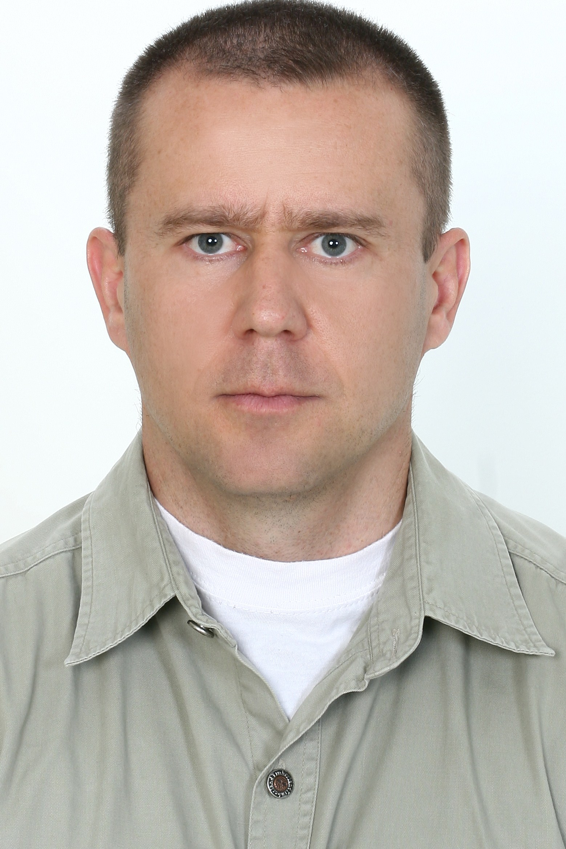
Jalkovecka 100 A
42000 Varaždin
CROATIA
Skype : zstrelec
E-mail: zstrelec75@gmail.com/ zstrelec@hotmail.com
Date of birth: 26 January 1975
FRENCH and CROATIAN nationality
SIA licensed

HIGH RISK AREA SECURITY OPERATOR

PROFESSIONAL EXPERIENCE
2016- 2017 Team leader in Maritime Defence Force
Vessels and tankers escorted through High Risk Area and duration:
*M/V Juist (multi-purpose); RDV Point 17 N Red Sea – Aden – Hazira – Nhava Sheva –
Fujairah OPL – 20 days
*M/V Medkon Sinop (general cargo);Fujairah OPL – Assab – RDV Point 17 N Red Sea – 10
days
*M/T Pretty World (oil/chemical);RDV Point 17 N Red Sea-Fujairah OPL – 7 days
*M/V Excellent (ro-ro);Suez- Djibouti-Jebel Ali- RDV Point 17 N Red Sea – 25 days
*M/V Esi Anax (general cargo); Suez - Galle – 14 days
*M/V Pacific Dawn (general cargo); RDV Point 17 N Red Sea- Galle – 9 days
*M/V Esbjerg (general cargo); Jebel Ali- RDV Point 17 N Red Sea – 9 days
*M/V Julie Delmas (container); Mombasa- Mogadishu- Salalah- Jebel Ali- Khor Fakkan-
Mombasa- 122 days

2015 Security advisor MDF-BF (Burkina Faso)

2013- 2015 Team leader in Maritime Defence Force
Vessels and tankers escorted through High Risk Area and duration:
*M/V Michigan (general cargo); Suez- Galle- 12 days
*M/V Langeoog (general cargo); Suez- Mogadishu- Durban- Fujairah OPL - 37 days
*M/V CMA CGM Kailas (container); Mombasa- Mogadishu- Jebel Ali- Khor Fakkan-
Mombasa- 96 days
*M/V N-Discovery (bulk carrier); Galle- Suez – 13 days
*M/V Bravo (container); Dar es Salaam- Port Klang- Singapore- Colombo - Male- Mombasa-
Dar es Salaam – 56 days
*M/V HS Haydn (container); Durban- Port Elizabeth- Port Louis- Jebel Ali- Salalah- Port
Reunion- Port Louis- Toamasina- Durban – 117 days
*M/T Kokuka Vigorous (chemical); Galle- Al Jubail- Galle – 18 days
*M/V Esbjerg (general cargo); Point 17 N, Red Sea- Fujairah - 8 days
*M/T Ayacucho (VLCC); Fujairah- Durban - 15 days
*M/T St. Marien (chemical); Galle- Suez – 14 days
*M/V Transtime (bulk carrier); Fujairah- Mombasa- Tanga- Dar es Salaam - Durban -31 day
*M/T Dawn (chemical); Suez- Kandla- Fujairah – 18 days
*M/V Imara (container); Colombo- Singapore- Tanjoung Pelepas- Colombo- Mombasa-
Dar es Salaam- Colombo – 34 days

2012 Private security officer
1994- 2012 17 years and 6 months in the French Foreign Legion, NCO
Sergeant First Class
*Recruiter at the Information Unit of the Foreign Legion in Lyon
*Military Police platoon leader in the 13th DBLE (13th Half-brigade of the Foreign Legion –Djibouti)
*Instructor to NCO students
*Staff sergeant in various operational missions (Chad, Djibouti, Kosovo, Macedonia)
*Team leader
1993-1994  EDUCATION  2017 | *Grenadier-rifleman  Grenadier-rifleman in the Croatian army  SIA Close protection L3 – BSA – Serbia  MIRA– BSA – Serbia  FPOSI L3, AoFAQ – BSA – Serbia
2013  2012  2011  2006  2005  2001  1996  1992 | Maritime security operator (MSO) - Surtymar- France  Ship security officer (SSO ) - Surtymar- France  Prevention of acts of piracy and armed robbery training (BMP)- Surtymar- France  Maritime firearms competency certificate - Simar- France  Helicopter underwater escape training (HUET) - Apave Mare- Croatia  Basic safety training - STCW95 (INS.E.I.T.- France)  *Personnal survival techniques (A-VI/1-1)  *Fire prevention and fire fighting (A-VI/1-2)  *Medical first aid and medical care (A-VI/1-3)  *Personnal safety and social responsibility (A-VI/1-4)  Sea Marshall (Special practical training for PCASP in the International Security Academy- Israel)  PSO (Formaplus – France)  Higher technician in control and operational management, option: infantry (Bachelor's Degree-level accredited)  Instructor in combat shooting techniques in the 4th RE (4thFrench Foreign Regiment- Castelnaudary)  Instructor in commando techniques in the 2nd REI (2nd Infantry Regiment- Nimes)  Assistant forest-combat instructor at the training center in the equatorial forest – 3rd REI (3rd French Foreign Infantry Regiment- French Guyana)  BAC PRO (A-level) in hotel management and catering
SKILLS
Security: armed and unarmed protection methods, leading anti-piracy crew awareness and drills on board ships, maintaining and supervising the implementation of the ship security plan, undertaking regular security inspections of the ship, organising and leading patrols, escorting convoys, first aid
Team management: providing adequate technical, tactical and theoretical training to shipboard security personnel, establishing service schedules, enhancing security awareness and vigilance on board
Additional skills: ensuring that security equipment (weapons, optics and radios) is properly operated, tested, calibrated and maintained, supervising vehicle fleets, use of computer tools (Windows XP, Word, Excel)
Languages: English, French, Croatian

SOFT SKILLS
Highly self motivated and disciplined individual who possesses high endurance and strong leadership qualities, reinforced by more than 17 years of active service in the French Foreign Legion. Sense of observation, analysis and reflection, punctual and rigorous, ability to adapt and provide information reports to hierarchy, sense of initiative, decision-making and operational action, ability to listen and work in a team, availability, discipline, discretion, self-control.

MISCELLANEOUS INFORMATION
Seaman’s Book
ENG1 certificate issue by French Maritime and coastguard agency
Yellow fever vaccination up to 2025
Anti-tetanus (dTCP) vaccination up to 2022
Interests: running, hiking and travel
Driving license: B, C

